

Name: Krishnaraj Prashant Thadesar. Class: F.Y B.Tech Division 9. Batch: I3.

Roll No.: 109054 Expt. No. 3 .

Performed on: 13/09/21 . Submitted on: 18/09/21 . Teacher’s Sign.: .

**To Find the Law of Machine of a Simple Lifting Machine**

***Purpose of the experiment:***

To study the performance of simple lifting machines and to establish the law of machines for the same

***Instruments****:*

Lifting machines, (Worm and worm wheel, second system of Pulleys, Compound Wheel and Axle), weights, hangers, scale.

***Theory:***

*Mechanism*:It is a system of rigid bodies connected together and capable of undergoing displacement.

*Machine*: It is a mechanism that is used for overcoming a resistance at one point by the application of a force at some other defined point in mechanism.

*Load(W):* The resistance offered by the body that the machine has to overcome to lift it is called the load.

*Effort (P):* The force which is required for overcoming the resistance is called as the Effort.It is the power directly applied to a machine to lift a load. It is denoted by P.

*Mechanical Advantage*:

Lifting Machines are used for overcoming a large resistance by application of small effort. The ratio

$$\frac{Load}{Effort}=\frac{W}{P}$$

Is defined as the mechanical Advantage.

*Velocity Ratio:*

If the displacement of the effort is denoted by ‘b’ and the corresponding displacement of the load is denoted by ‘a’ during the same time internal ‘t’

The Ratio is defined as

$$Ratio=\frac{Displacement of effort in time t}{Displacement of load in time t}= \frac{Velocity of Effort}{Velocity of Load}= \frac{b/t}{a/t}=\frac{b}{a}$$

It is denoted by ‘v’. This velocity ratio is constant for any given machine and depends purely on the geometrical configuration of load and effort exerting mechanism and is independent of the load or effort.



*Efficiency*:

The ratio of useful work got out of the machine to the work put in by the effort is defined as the ‘efficiency’ eta of the machine and is usually expressed as a percentage.

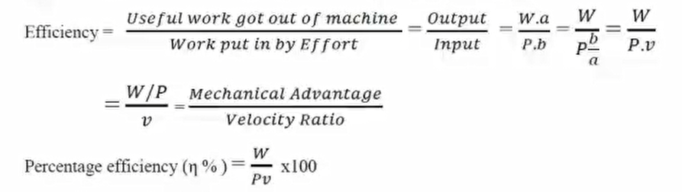

Similarly, with a given effort t P, the ideal load that would have been lifted if there were no friction should have been Pv.

Therefore efficiency

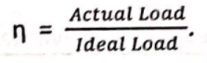

The measure of friction in the machine can be state in two ways. If ‘P’ is the actual effort for a given load, W, the idea effort should have been $\frac{W}{v}$

Therefore,

*effort lost in friction = P – $\frac{W}{v}$*

We may also say that for a given effort to lift a load W the idea load lifted should have been Pv.

*Frictional load = PV-W*

The mechanical Advantage of the machine and hence loss of effort due to friction will depend upon how well the machine is maintained by lubrication.

*Law of Machine:*

If efforts ‘P’ corresponding to various loads W are plotted, it will generally be found that the relationship between the two is a linear one. Which can eb expressed as

$$P = mW + C$$

Where m – slope of the load effort, graph and C = intercept on effort axis.



*Maximum Efficiency*

*η­­max = * 100.*

If it is greater than 50% then the machine is reversible, else it is irreversible.

***Procedure:***

1. Study the arrangement of the machine. Measure the required dimensions and find out the velocity ratio v.
2. Note down the point of application of load and effort.
3. Apply known weight (Load) W and apply just that effort at which the effort moves with uniform velocity.
4. Note efforts ‘P’ for various values of loads ‘W’
5. Plot Graphs of
   1. Load (W) against Effort (P)
   2. Load (W) against effort lost in friction (Pf)
   3. Load (W) against efficiency (η)



#### *Observations and Calculations: -*

* + 1. Compound Wheel and Axle: Velocity ratio v =

|  |  |  |  |  |  |
| --- | --- | --- | --- | --- | --- |
| Sr.  No. | Load W | Effort P | Frictional Effort Pf =P-(W/v) | Mechanical advantage (W/P) | Efficiency η = (W/Pv) |
| 1. |  |  |  |  |  |
| 2. |  |  |  |  |  |
| 3. |  |  |  |  |  |
| 4. |  |  |  |  |  |
| 5. |  |  |  |  |  |

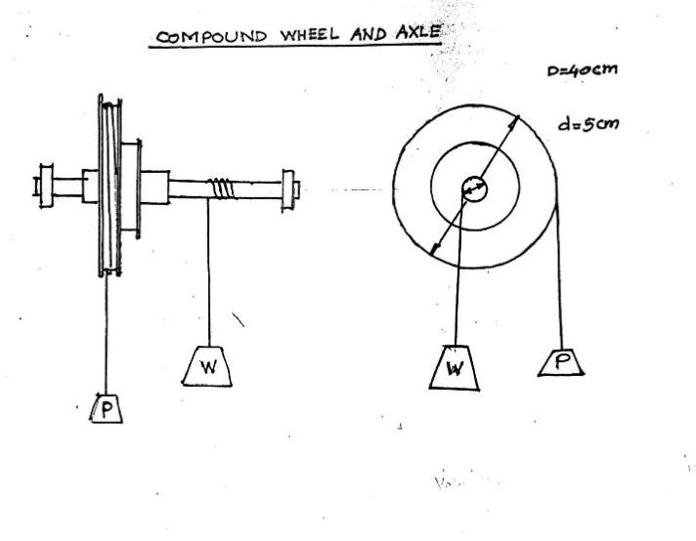

**Fig. 1: Compound Wheel and Axle.**



* + 1. Worm and worm wheel: Velocity ratio v = 80

|  |  |  |  |  |  |
| --- | --- | --- | --- | --- | --- |
| Sr.  No. | Load  W | Effort  P | Frictional Effort Pf =P-(W/v) | Mechanical advantage (W/P) | Efficiency η = (W/Pv) |
| 1. | 1.0 | 0.100 | 0.0875 | 10.0 | 12.5 |
| 2. | 1.2 | 0.120 | 0.1050 | 10.0 | 12.5 |
| 3. | 1.4 | 0.140 | 0.122 | 10.0 | 12.5 |
| 4. | 1.6 | 0.150 | 0.130 | 10.66 | 13.325 |
| 5. | 1.8 | 0.170 | 0.148 | 10.58 | 13.225 |

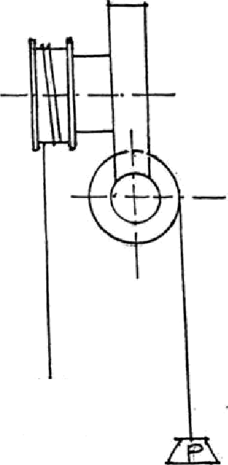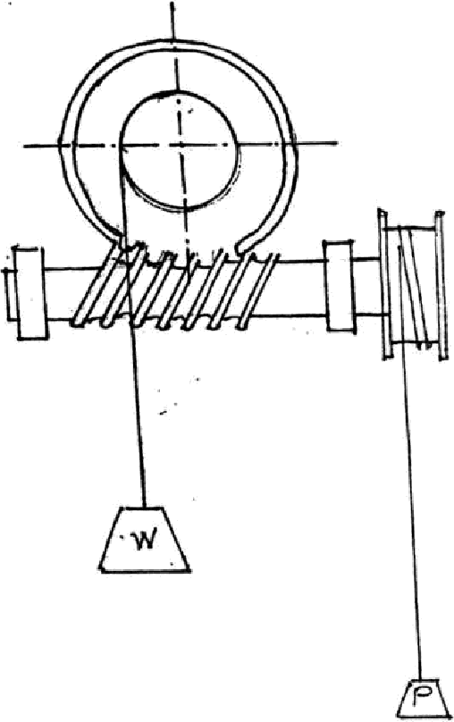**Fig. 2: Worm and Worm Wheel**



1. Second system of pulleys: Velocity ratio v = 6

|  |  |  |  |  |  |
| --- | --- | --- | --- | --- | --- |
| Sr.  No. | Load  W | Effort  P | Frictional Effort Pf =P-(W/v) | Mechanical advantage (W/P) | Efficiency η = (W/Pv) |
| 1. | 1.0 | 0.277 | 0.110 | 3.610 | 60.16 |
| 2. | 1.2 | 0.317 | 0.117 | 1.785 | 63.08 |
| 3. | 1.4 | 0.382 | 0.148 | 3.665 | 61.08 |
| 4. | . 1.6 | 0.430 | 0.163 | 3.720 | 62.0 |
| 5. | 1.8 | 0.480 | 0.180 | 3.750 | 62.5 |

**Note: Students are instructed to do all the necessary calculation on separate sheets Separate graph papers should be used for each machine**

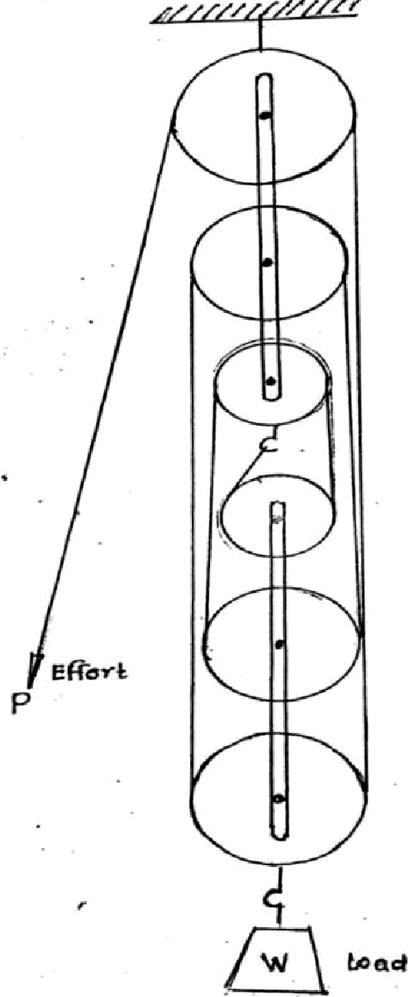

**Fig. 3: Second System of Pulleys**



***Graphs:***





#### *Conclusion:*

#### The Law of machines gives:

#### P =mW + C

#### For Worm and Worm wheel, the value of m from the graph is 0.1, and velocity ratio is 80

#### For Second system of Pulleys, the value of m from the graph is 0.325, and the velocity ratio is 6

#### Efficiency for *Worm and Worm Wheel* = η = 100/mv = 100/ (0.1 * 80) = 12.5%, which is less than 50% and is so it is an *irreversible machine*

#### Efficiency for *Second System of Pulleys* = η = 100/mv = 100/ (0.325 * 6) = 51.28 %, which is more than 50%, So it is a *reversible machine.*

|  |  |  |
| --- | --- | --- |
| Name of Machine | Law of Machine | Max Efficiency |
| Worm and Worm Wheel | P = 0.1W +C | **12.5%,** |
| Second System of Pulleys | P = (0.325) W + C | **51.28 %,** |

#### Questions: -

1. Define the following terms: a) Mechanical Advantage b) Velocity Ratio c) efficiency of machine.

A. Mechanical Advantage : Lifting Machines are used for overcoming a large resistance by application of small effort. The ratio load/effort i.e., w/p is defined as mechanical advantage.

B. Velocity Ratio : If the displacement of the effort is denoted by ‘b’ and the corresponding displacement of the load is denoted by ‘a’ during the same time internal ‘t’

The Ratio is defined as

$$Ratio=\frac{Displacement of effort in time t}{Displacement of load in time t}= \frac{Velocity of Effort}{Velocity of Load}= \frac{b/t}{a/t}=\frac{b}{a}$$

C. Efficiency of Machine : The ratio of useful work got out of the machine to the work put in by the effort is defined as the ‘efficiency’ eta of the machine and is usually expressed as a percentage.

$$η= \frac{100}{mv}$$

1. What is the difference between reversible and irreversible machine?

*η­­max = * 100.*

If it is greater than 50% then the machine is reversible, else it is irreversible.



1. What is the law of a machine?
   * 1. If efforts ‘P’ corresponding to various loads W are plotted, it will generally be found that the relationship between the two is a linear one. Which can be expressed as

P = mW + C

1. State the practical applications where simple lifting machines are commonly used.

A. Simple lifting machines are used in:

1. Wells
2. Car jacks
3. Forklifts
4. Why is the efficiency of the machine less than one?
5. The percentage of the work input that becomes work output is the efficiency of a machine. Because there is always some friction, the efficiency of any machine is always less than 100 percent.